Jamboree 2017 Image result for pee dee council bsa

Volume 1, Issue 2 November 2016

Important Dates

Here are some key dates to put on your calendar:

* January 21th First Contingent Meeting – Parent and Scout Meet and Greet **\*New Date\***
* March 11th Troop Meeting
* May 5-7 Pre-Jamboree experience encampment
* June 29th Last Contingent Meeting
* July 18th Leave to Jamboree
* July 28th Get back home.

Communication

Everyone should have received an email from Scoutlander to join Troop 1. This is our website that has the latest information about the Jamboree. We want to ensure everyone is informed about what is going to happen and to ensure everyone know the important dates of all of the contingent meetings. As we get closer you will see additional information through the website, newsletters and email. If you have not received this email or need to reset your password, please contact Brad at [brad.mckee@live.com](mailto:brad.mckee@live.com)

We have a facebook page for Jamboree at: <https://www.facebook.com/Georgia-Carolina-Council-2017-Jamboree-185379998210288/?fref=ts>

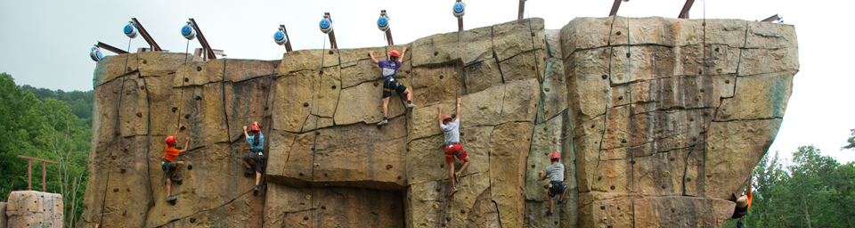

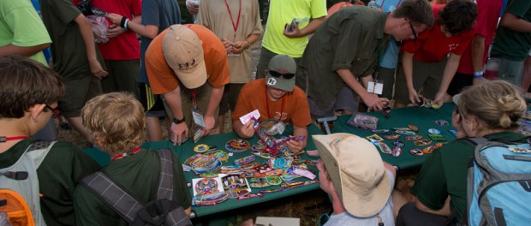

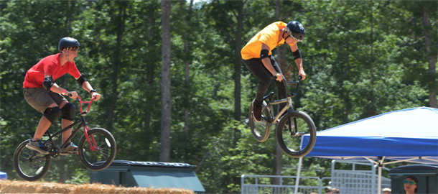

Jamboree Updates

We are now less than 250 days before we leave to Jamboree. There have been lots of updates over the past month including:

* Please welcome Julie Thornton who will be leading the venture crew number 5248C. We are excited that she has stepped up to lead the crew.
* We have our Troop numbers now Troop 4324 (Pee Dee and part of Georgia/Carolina Council) and Troop 4325 (Which will consist of all of Georgia/Carolina)
* We have changed our first meeting to January 21st because the previous date was on a holiday. Location TBA
* We are now full with a waiting list for both our Troops and Crew. If you still know someone who wants to come. They need to contact the council office to be put onto the waiting list

There is a lot of information about the Jamboree located at: <http://www.summitbsa.org/events/jamboree/overview/>

PAYMENTS ARE DUE

***Georgia Carolina Council***

We need your payments! The cost of the Jamboree for the council of over $100K, and the council needs everyone to get their payments in. We realize that as parents this is a challenge to keep up with the payments, but the council has already made several payments to ensure a spot is guaranteed. However, we believe your son or daughter will have an amazing Jamboree experience that will last a lifetime. We have payments that are due to the National Jamboree, bus providers and other expenses. Getting or staying current on your jamboree payments is critical so that we can make these payments on time and receive discounts to maintain our cost structure. PLEASE make every effort to get caught up and make your Jamboree payment. All payments should be made through Regina at the scout office at 706-733-5277.

Payment schedule:

January 15, 2016 - $325

April 15, 2016 - $325

July 15, 2016 - $325

October 15, 2016 – $300

January 15, 2017 - $275

***Pee Dee Council***

Please remember to continue to make payments to the Pee Dee Council office. Please contact them at (843) 662-6306

Mett your Scoutmaster Staff

Here is the list of the Scoutmaster staff for Jamboree.

***Troop 4324***

* Scoutmaster: Mark Hall
* Assistant Scoutmasters: Reed Miller, Greg Thompson

***Troop 4325***

* Scoutmaster: Chris Bennett
* Assistant Scoutmasters: Brad McKee, Ed Shannon

***Venture Crew 5248C***

* Julie Thornton

We will be finalizing the third Assistant Scoutmaster soon.

Why do you need to go to all the contingent meetings?

To ensure each scout gets their money worth out of Jamboree, it is extremely important to each contingent meetings. We will have scouts in our troops from two councils and there are only an handful of scouts who know each other. During the meetings there will be lots of information given out as well as tons of bonding experiences. It is strongly recommended that every scout should attend every meeting and treat it like this is their new temporary troop.

The Pre-Jamboree experience encampment is required for every scout to attend on May 5-7, 2017. The experience will have team building games, Jamboree Camp set-up, food and fun

BSA Medical Forms

The Annual Health and Medical Record (AHMR) is mandatory to attend the 2017 National Scout Jamboree. Submission of the AHMR will be an online, multi-step process. Your AHMR data will be kept on a secure, password protected server.  After AHMR submission, it will undergo a medical review for approval to participate in the Jamboree at the Summit. You will be notified by email when the AHMR has been approved.

The AHMR must be within 1 year of the Jamboree so it cannot be dated before July 29, 2016.  The electronic AHMR process required for the Jamboree will be made available beginning July 19, 2016. More details about that process will be sent by email on or around July 19th.

continued on page 2

|  |  |
| --- | --- |
| Inside This Issue | |
| 1 | Jamboree Updates |
| 1 | Key Dates |
| 2 | Payments |
| 3 | Contact Information |
| 4 | Questions and Answers |



continued on page 3

continued from page 1

What to expect for during the first day of Jamboree

The Jamboree is a long drive up, so we thought it would be best to sleep on it. Buses will be departing from two locations. The two buses will be picking up the Georgia/Carolina Council at the council office on Tuesday night July 18th, time TBA. Then we will be driving up to the Columbia, SC area to pick up the Pee Dee scouts. From there we will travel overnight to West Virginia while sleeping on the bus. Our check in currently for Jamboree will be around 6-7am on Wednesday morning. After check-in we will proceed to our designated campsite and set-up camp. Our goal is to have our camp set-up by early afternoon so all of the scouts can enjoy the events as soon as they open.

Contact Information

**Georgia/Carolina Council**

**Brad McKee** [**brad.mckee@live.com**](mailto:brad.mckee@live.com)

**Chris Bennett** [**Eaglescout81@comcast.net**](mailto:Eaglescout81@comcast.net)

**Ed Shannon** [**eds67olds@yahoo.com**](mailto:eds67olds@yahoo.com)

**Reed Miller** [**wrmusa@gmail.com**](mailto:wrmusa@gmail.com)

**Julie Thornton jthornton94@yahoo.com**

**Pee Dee Council**

**Mark Hall** [**hall35mark@yahoo.com**](mailto:hall35mark@yahoo.com)

**Greg Thompson** [**gregtbeach@yahoo.com**](mailto:gregtbeach@yahoo.com)

continued from page 1

Questions and Answers

Q: How do we get the food during the Jamboree?

A: For Breakfast and Dinner it will be troop cooking and a trail lunch. There will be a central area in each sub camp which representatives for each troop will go shopping for the troop on a points system. This was tried out during the last World Jamboree and it was very successful. It also gave a larger variety to the troop of what they could eat.

Q: Do we get a Duffle bag of patches?

A: Every Scout will receive one Jamboree Duffle bag which all personal gear should fit in. The Capacity of the duffel bag is 130 liters, approx.. 33”L x 22” W x 14”D. Manufactured by Osprey, includes shoulder straps and the 2017 Jamboree logo. Everyone will need to bring their own day pack

Q: Can I earn Merit Badges while I am there?

A: Yes, there is an opportunity to earn several merit badges while at Jamboree. Stay TBA at later date.

Q: How many different events are at Jamboree?

A: There are over 300 events during the Jamboree including high adventure activities, sports, and concerts.

Q: Will we be doing any community service as a Troop?

A: Yes. During one day of the Jamboree the entire Troop/Crew will be doing a day of service in one of the communities around the Summit. There will be more information when we get closer.

Q: Is there showers and running water?

A: Yes. There are showers and flush toilets near each campsite, but it may not be too warm. The Summit has plan to get the showers warmer, but there is not guarantee. It is suggested to bring a Sunshower of 2.5 gallons or less to have a hot shower.

Q. Can we buy additional food during the day?

A: There will be vendors there so you can buy additional food, candy and drinks. The Jamboree provides the main meals, but does not provide any snacks.

